The UML section of the project mostly describes the main function of the Snake Game but also models the menu and submenus. The Activity Diagram models what the user would do if they only selected the Play Game Option from the menu. Once that has been selected the Load Game state starts movement of the snake and generation of food. A Main Loop constantly detects input from the user and puts it through a Second Loop which checks to see if the snake has hit the Snake Body or a wall. If it is not hit it then checks to see if food has been eaten. If it has it adds one to the Snake Body and generates a new food on the screen, otherwise it loops back to the Second Loop conditions. If one of the prerequisites are fulfilled then it ends the game and displays the end screen which is the leaderboards. There is then an option to continue playing, which goes back to Load Game state, otherwise it ends and exits the program.
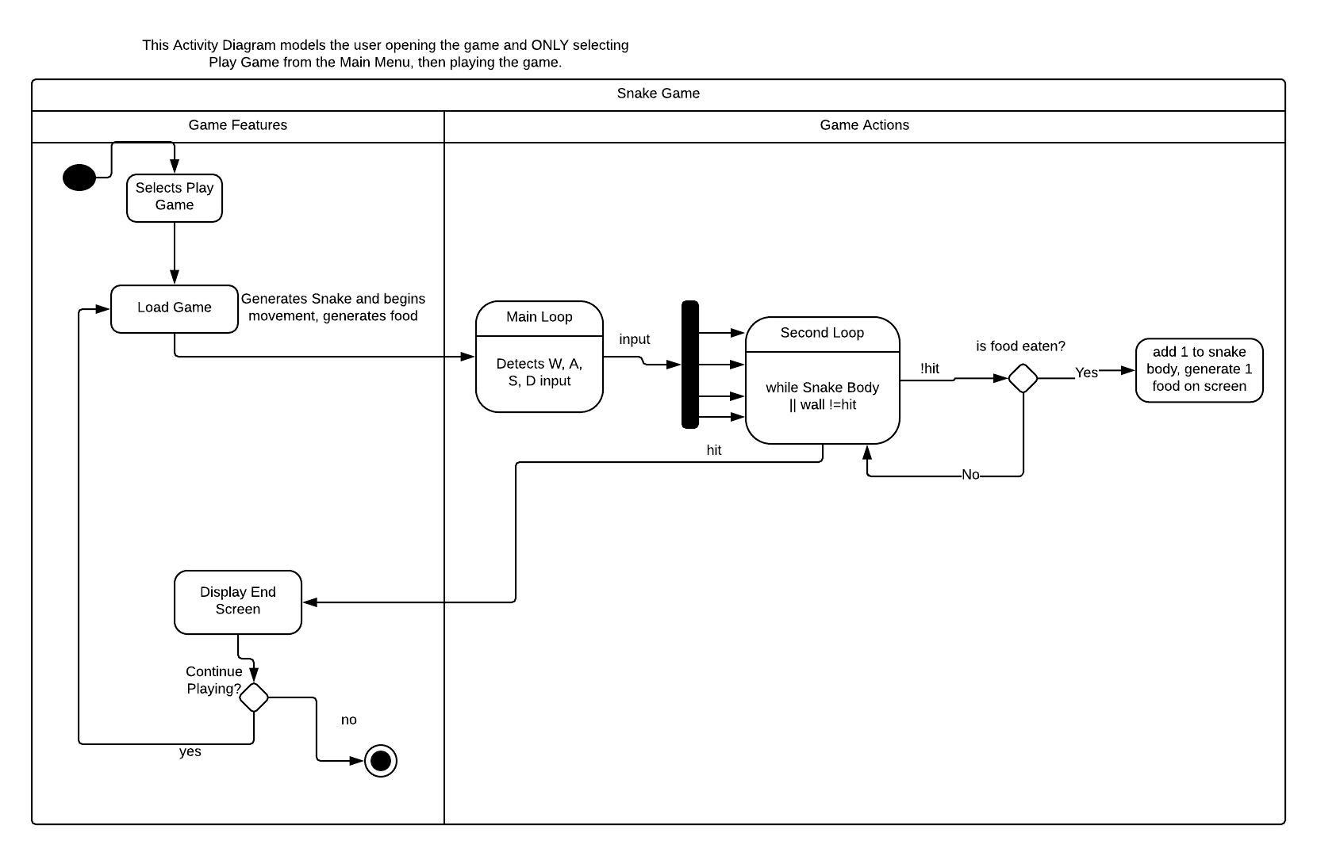

The Class Diagram outlines the structure of the menu and submenus. There is one Main Menu with 4 other options. 2 of the options include submenus, the other 2 do not have submenus. There is also an Exit button present at all times except for during a game of snake so that you can exit the program at any time. Going through logically, the first part of the main menu is Start Game. This generates the play screen, the snake color and speed, along with the initial starting food. The second selection is the Options which includes a submenu inside. In this menu there is a Color Drop Menu, Snake Speed adjuster, Snake and Food Size Drop Menu, No Borders option, Random Function, and a Reset to default settings button. There is also a Back button which returns to the main menu. The third option is a High Scores or Leaderboard screen which displays the top 5 highscores, a feature to submit your own score, a Play button to begin a game and a Back button to return to the Main Menu. The fourth option is the Exit button which exits the program entirely.

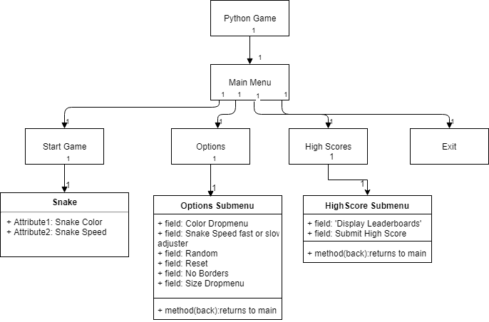

The Sequence Diagram is a more specific diagram in which it models the gameplay of the Snake Game. The player chooses Start Game from the Main Menu, it sends a message to load the Game Screen then another message to load the Snake. A return message from the Snake object is sent to start moving the snake on the Game Screen. The Game Screen then returns a message to the player which allows for keyboard input. The diagram then enters a loop which keeps looping until the Snake Body or a Wall is hit. In this loop the user enter keyboard input which sends a message directly to the Snake. The Snake then returns a message to the Game Screen which displays the adjustment, the Game Screen then sends another return message allowing further keyboard input. Inside this loop is an alt which occurs when food is eaten, otherwise it does nothing. Inside the alt when a food is eaten a message is sent from the player to the Game Screen to generate another block. The Game Screen generates another block and then sends a message to the Snake to add one block to the Snake tail. The Snake then sends a return message and exits out of the alt statement. If the condition for the while loop is not meant (ex. a wall is hit) the player sends a message to the End Screen object which ends the game and displays the high scores. After that the process is completed and a return message is sent to the Player from the End Screen and then exits to the Main Menu.
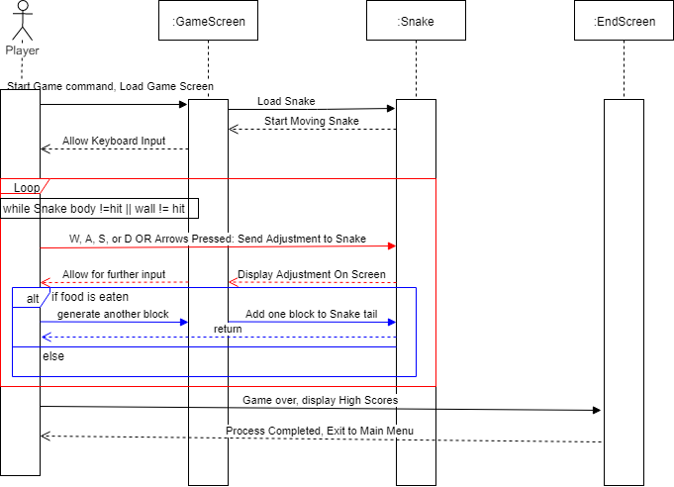
The State Chart diagram, similar to the Sequence Diagram models the main gameplay of the Snake during the Game. In the Main Menu state the StartGame is selected which then goes into the Game State. In the Game State the Snake Moving state begins and the action inside adjusts to the user input. Ate food is sensed and sent to the Eaten Food state which then returns to the Snake Moving State for further input. In between those two states is a branch that senses if a wall or Snake body is hit, if that is the case it then ends the game and exits the Game State. It goes to a Display High Scores state which gives the user the option of Playing Again or going Back. The former returns to the Game State just as if it was a new game, the latter goes back to the Main Menu.
